IKEA Sliding Cupboard

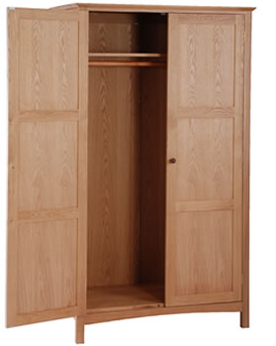

|  |
| --- |
| **DESCRIPTION** |
| IKEA dream designing has introduced a small multi storage cupboard with two sliding doors. The cupboard has a nice feel with smooth surface and brown charcoal material embedded with wooden paint absorbs heat to keep everything smooth inside. It will give your house a complete different look and a door with multi space stores long and wide valuables that easy adjust in such space. |

|  |  |  |
| --- | --- | --- |
| **Price** | **550$** | |
| **Dimensions** | **H** x **W** x **L** | **60in x 20in x 40in** |
| **Features** | **The two shelves are built only to hang clothes and insert items which are small in size.** | |
| **Finished** | **Charcoal Walnut** | |
| **Available in** | **Brown and Blue** | |